**Exercise 1: Configuring a Basic Spring Application**

Maven project name : **LibraryManagement**

**pom.xml :**

<project xmlns="http://maven.apache.org/POM/4.0.0"

xmlns:xsi="http://www.w3.org/2001/XMLSchema-instance"

xsi:schemaLocation="http://maven.apache.org/POM/4.0.0 https://maven.apache.org/xsd/maven-4.0.0.xsd">

<modelVersion>4.0.0</modelVersion>

<groupId>com.library</groupId>

<artifactId>LibraryManagement</artifactId>

<version>1.0</version>

<properties>

<spring.version>5.3.29</spring.version>

</properties>

<dependencies>

<!-- Spring Core -->

<dependency>

<groupId>org.springframework</groupId>

<artifactId>spring-context</artifactId>

<version>${spring.version}</version>

</dependency>

</dependencies>

</project>

**applicationContext.xml :**

<?xml version="1.0" encoding="UTF-8"?>

<beans xmlns="http://www.springframework.org/schema/beans"

xmlns:xsi="http://www.w3.org/2001/XMLSchema-instance"

xsi:schemaLocation="http://www.springframework.org/schema/beans

http://www.springframework.org/schema/beans/spring-beans.xsd">

<bean id="bookRepository" class="com.library.repository.BookRepository"/>

<bean id="bookService" class="com.library.service.BookService">

<property name="bookRepository" ref="bookRepository"/>

</bean>

</beans>

**BookRepository.java :**

package com.library.repository;

public class BookRepository {

public String getBookInfo() {

return "Sample Book Information from Repository";

}

}

**BookService.java :**

package com.library.service;

import com.library.repository.BookRepository;

public class BookService {

private BookRepository bookRepository;

public void setBookRepository(BookRepository bookRepository) {

this.bookRepository = bookRepository;

}

public String getBookDetails() {

return bookRepository.getBookInfo();

}

}

**LibraryApp.java :**

package com.library.LibraryManagement;

import org.springframework.context.ApplicationContext;

import org.springframework.context.support.ClassPathXmlApplicationContext;

import com.library.service.BookService;

public class LibraryApp {

public static void main(String[] args) {

ApplicationContext context = new ClassPathXmlApplicationContext("applicationContext.xml");

BookService service = context.getBean(BookService.class);

System.out.println("1. Spring context loaded successfully");

System.out.println("2. BookService bean created: " + service);

System.out.println("3. Book details: " + service.getBookDetails());

}

}

**OUTPUT:**

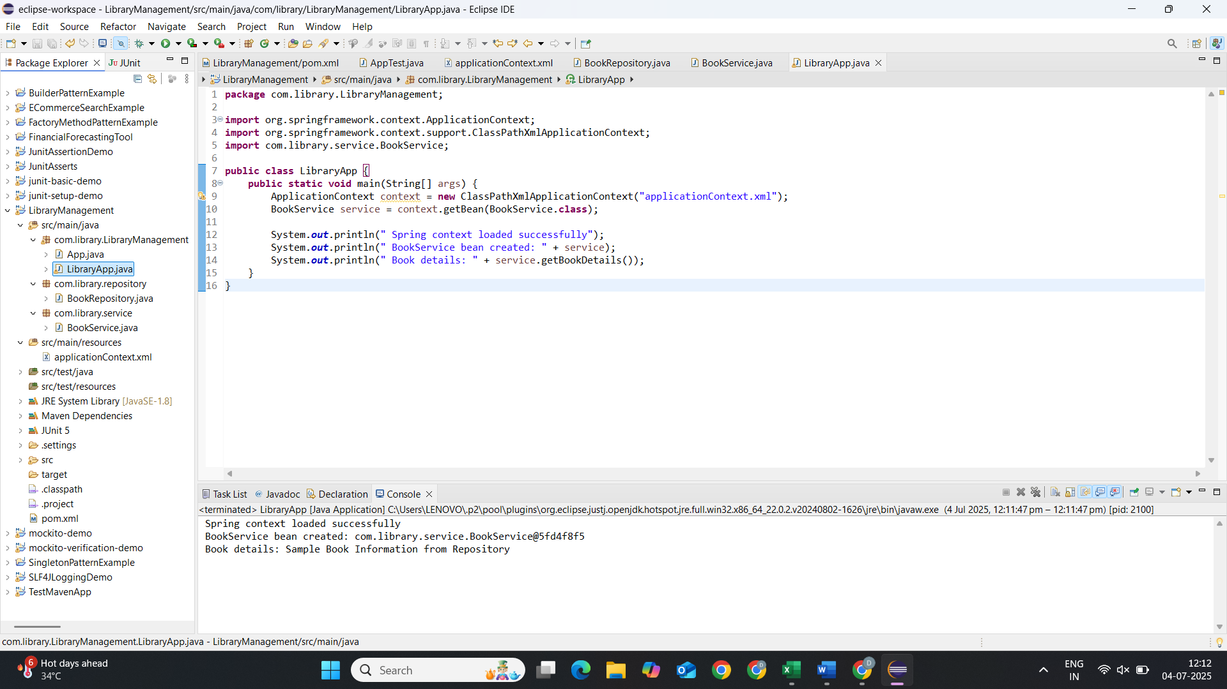

**Exercise 2: Implementing Dependency Injection**

**applicationContext.xml :**(Updating XML Configuration)

<?xml version="1.0" encoding="UTF-8"?>

<beans xmlns="http://www.springframework.org/schema/beans"

xmlns:xsi="http://www.w3.org/2001/XMLSchema-instance"

xsi:schemaLocation="http://www.springframework.org/schema/beans

http://www.springframework.org/schema/beans/spring-beans.xsd">

<!-- Define BookRepository bean -->

<bean id="bookRepository" class="com.library.repository.BookRepository"/>

<!-- Define BookService bean with dependency injection -->

<bean id="bookService" class="com.library.service.BookService">

<property name="bookRepository" ref="bookRepository"/>

</bean>

</beans>

**BookService.java :**

package com.library.service;

import com.library.repository.BookRepository;

public class BookService {

private BookRepository bookRepository;

public void setBookRepository(BookRepository bookRepository) {

this.bookRepository = bookRepository;

}

public String getBookDetails() {

return bookRepository.getBookInfo();

}

}

**BookRepository.java :**

package com.library.repository;

public class BookRepository {

public String getBookInfo() {

return "Sample book data from repository";

}

}

**LibraryManagementApplication.java :**

package com.library.LibraryManagement;

import org.springframework.context.ApplicationContext;

import org.springframework.context.support.ClassPathXmlApplicationContext;

import com.library.service.BookService;

public class LibraryManagementApplication {

public static void main(String[] args) {

// Load Spring context

ApplicationContext context =

new ClassPathXmlApplicationContext("applicationContext.xml");

// Get BookService bean

BookService bookService = context.getBean("bookService", BookService.class);

System.out.println("Book Details: " + bookService.getBookDetails());

((ClassPathXmlApplicationContext) context).close();

}

}

**OUTPUT:**

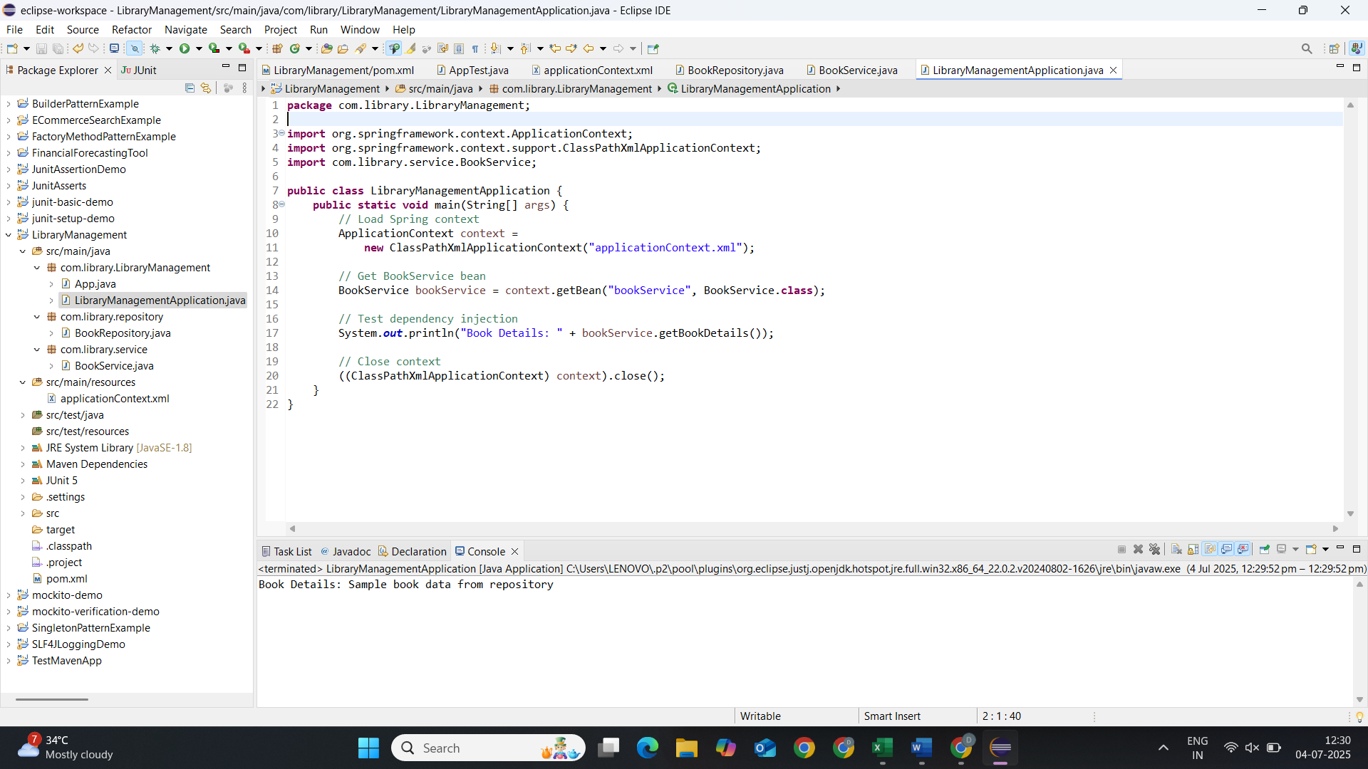

**Exercise 3: Implementing Logging with Spring AOP**

**pom.xml :**

<project xmlns="http://maven.apache.org/POM/4.0.0" xmlns:xsi="http://www.w3.org/2001/XMLSchema-instance"

xsi:schemaLocation="http://maven.apache.org/POM/4.0.0 http://maven.apache.org/xsd/maven-4.0.0.xsd">

<modelVersion>4.0.0</modelVersion>

<groupId>com.library</groupId>

<artifactId>LibraryManagement</artifactId>

<version>1.0</version>

<properties>

<spring.version>5.3.29</spring.version>

</properties>

<dependencies>

<!-- Spring Core -->

<dependency>

<groupId>org.springframework</groupId>

<artifactId>spring-context</artifactId>

<version>${spring.version}</version>

</dependency>

<!-- Spring AOP -->

<dependency>

<groupId>org.springframework</groupId>

<artifactId>spring-aop</artifactId>

<version>${spring.version}</version>

</dependency>

<!-- AspectJ -->

<dependency>

<groupId>org.aspectj</groupId>

<artifactId>aspectjweaver</artifactId>

<version>1.9.7</version>

</dependency>

</dependencies>

</project>

**LoggingAspect.java :**

package com.library.aspect;

import org.aspectj.lang.ProceedingJoinPoint;

import org.aspectj.lang.annotation.Around;

import org.aspectj.lang.annotation.Aspect;

import org.springframework.stereotype.Component;

@Aspect

@Component

public class LoggingAspect {

@Around("execution(* com.library.service.*.*(..))")

public Object logExecutionTime(ProceedingJoinPoint joinPoint) throws Throwable {

long startTime = System.*currentTimeMillis*();

System.*out*.println("Method " + joinPoint.getSignature() + " started execution");

Object result = joinPoint.proceed();

long executionTime = System.*currentTimeMillis*() - startTime;

System.*out*.println("Method " + joinPoint.getSignature() + " executed in "

+ executionTime + "ms");

return result;

}

}

**applicationContext.xml :** (Enable AspectJ Support in Configuration)

<?xml version="1.0" encoding="UTF-8"?>

<beans xmlns="http://www.springframework.org/schema/beans"

xmlns:xsi="http://www.w3.org/2001/XMLSchema-instance"

xmlns:aop="http://www.springframework.org/schema/aop"

xmlns:context="http://www.springframework.org/schema/context"

xsi:schemaLocation="

http://www.springframework.org/schema/beans https://www.springframework.org/schema/beans/spring-beans.xsd

http://www.springframework.org/schema/aop https://www.springframework.org/schema/aop/spring-aop.xsd

http://www.springframework.org/schema/context https://www.springframework.org/schema/context/spring-context.xsd">

<!-- Enable AspectJ auto-proxying -->

<aop:aspectj-autoproxy/>

<!-- Enable component scanning -->

<context:component-scan base-package="com.library"/>

<!-- Manual bean definitions -->

<bean id="bookRepository" class="com.library.repository.BookRepository"/>

<bean id="bookService" class="com.library.service.BookService">

<property name="bookRepository" ref="bookRepository"/>

</bean>

</beans>

**LibraryManagementApplication.java:**

package com.library.LibraryManagement;

import org.springframework.context.ApplicationContext;

import org.springframework.context.support.ClassPathXmlApplicationContext;

import com.library.service.BookService;

public class LibraryManagementApplication {

public static void main(String[] args) {

ApplicationContext context =

new ClassPathXmlApplicationContext("applicationContext.xml");

BookService bookService = context.getBean(BookService.class);

// Call multiple times to see logging

bookService.getBookDetails();

bookService.getBookDetails();

((ClassPathXmlApplicationContext) context).close();

}

}

**OUTPUT:**

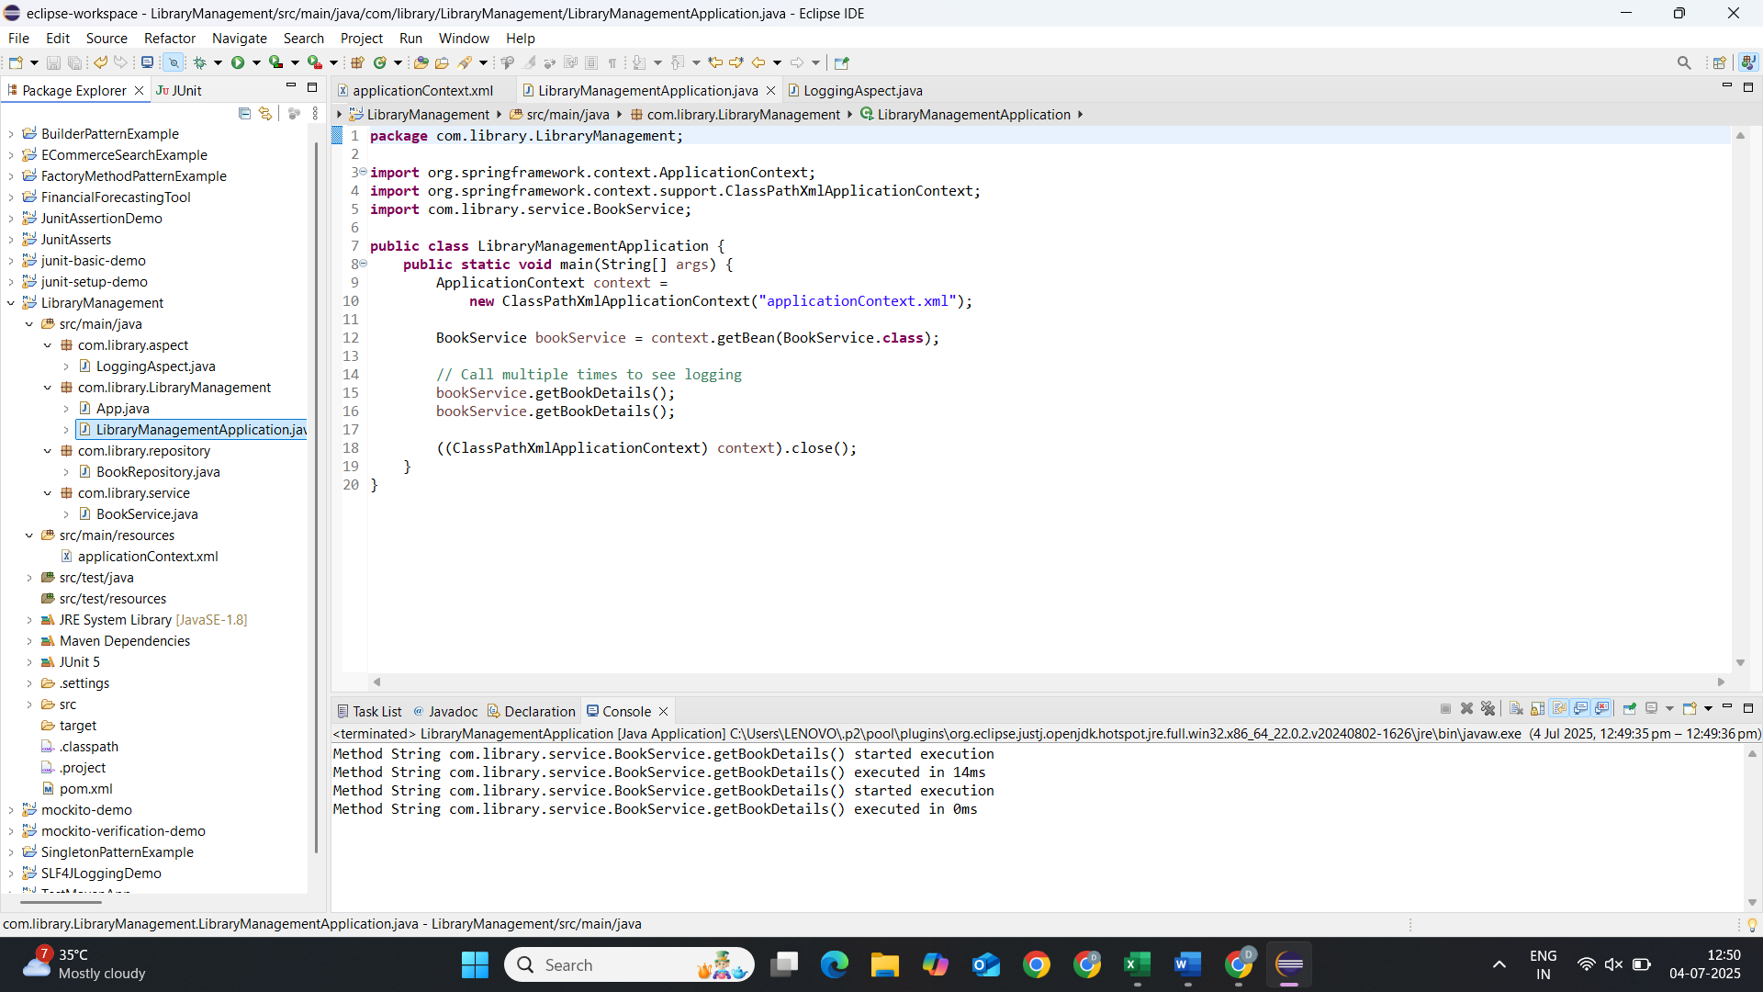

**Exercise 4: Creating and Configuring a Maven Project**

**pom.xml :**

<project xmlns="http://maven.apache.org/POM/4.0.0"

xmlns:xsi="http://www.w3.org/2001/XMLSchema-instance"

xsi:schemaLocation="http://maven.apache.org/POM/4.0.0

https://maven.apache.org/xsd/maven-4.0.0.xsd">

<modelVersion>4.0.0</modelVersion>

<groupId>com.library</groupId>

<artifactId>LibraryManagement</artifactId>

<version>1.0.0</version>

<packaging>jar</packaging>

<properties>

<project.build.sourceEncoding>UTF-8</project.build.sourceEncoding>

<java.version>1.8</java.version>

<spring.version>5.3.29</spring.version>

</properties>

<dependencies>

<!-- Spring Context (Core) -->

<dependency>

<groupId>org.springframework</groupId>

<artifactId>spring-context</artifactId>

<version>${spring.version}</version>

</dependency>

<!-- Spring AOP -->

<dependency>

<groupId>org.springframework</groupId>

<artifactId>spring-aop</artifactId>

<version>${spring.version}</version>

</dependency>

<!-- Spring Web MVC -->

<dependency>

<groupId>org.springframework</groupId>

<artifactId>spring-webmvc</artifactId>

<version>${spring.version}</version>

</dependency>

<!-- AspectJ for AOP -->

<dependency>

<groupId>org.aspectj</groupId>

<artifactId>aspectjweaver</artifactId>

<version>1.9.7</version>

</dependency>

</dependencies>

<build>

<plugins>

<!-- Maven Compiler Plugin -->

<plugin>

<groupId>org.apache.maven.plugins</groupId>

<artifactId>maven-compiler-plugin</artifactId>

<version>3.8.1</version>

<configuration>

<source>${java.version}</source>

<target>${java.version}</target>

</configuration>

</plugin>

</plugins>

</build>

</project>

**applicationContext.xml :**

<?xml version="1.0" encoding="UTF-8"?>

<beans xmlns="http://www.springframework.org/schema/beans"

xmlns:xsi="http://www.w3.org/2001/XMLSchema-instance"

xmlns:context="http://www.springframework.org/schema/context"

xmlns:aop="http://www.springframework.org/schema/aop"

xsi:schemaLocation="http://www.springframework.org/schema/beans

http://www.springframework.org/schema/beans/spring-beans.xsd

http://www.springframework.org/schema/context

http://www.springframework.org/schema/context/spring-context.xsd

http://www.springframework.org/schema/aop

http://www.springframework.org/schema/aop/spring-aop.xsd">

<context:component-scan base-package="com.library"/>

<aop:aspectj-autoproxy/>

</beans>

**MainApp.java :**

package com.library.LibraryManagement;

import org.springframework.context.ApplicationContext;

import org.springframework.context.support.ClassPathXmlApplicationContext;

public class MainApp {

public static void main(String[] args) {

ApplicationContext context =

new ClassPathXmlApplicationContext("applicationContext.xml");

System.out.println("Spring context loaded successfully!");

}

}

**OUTPUT :**

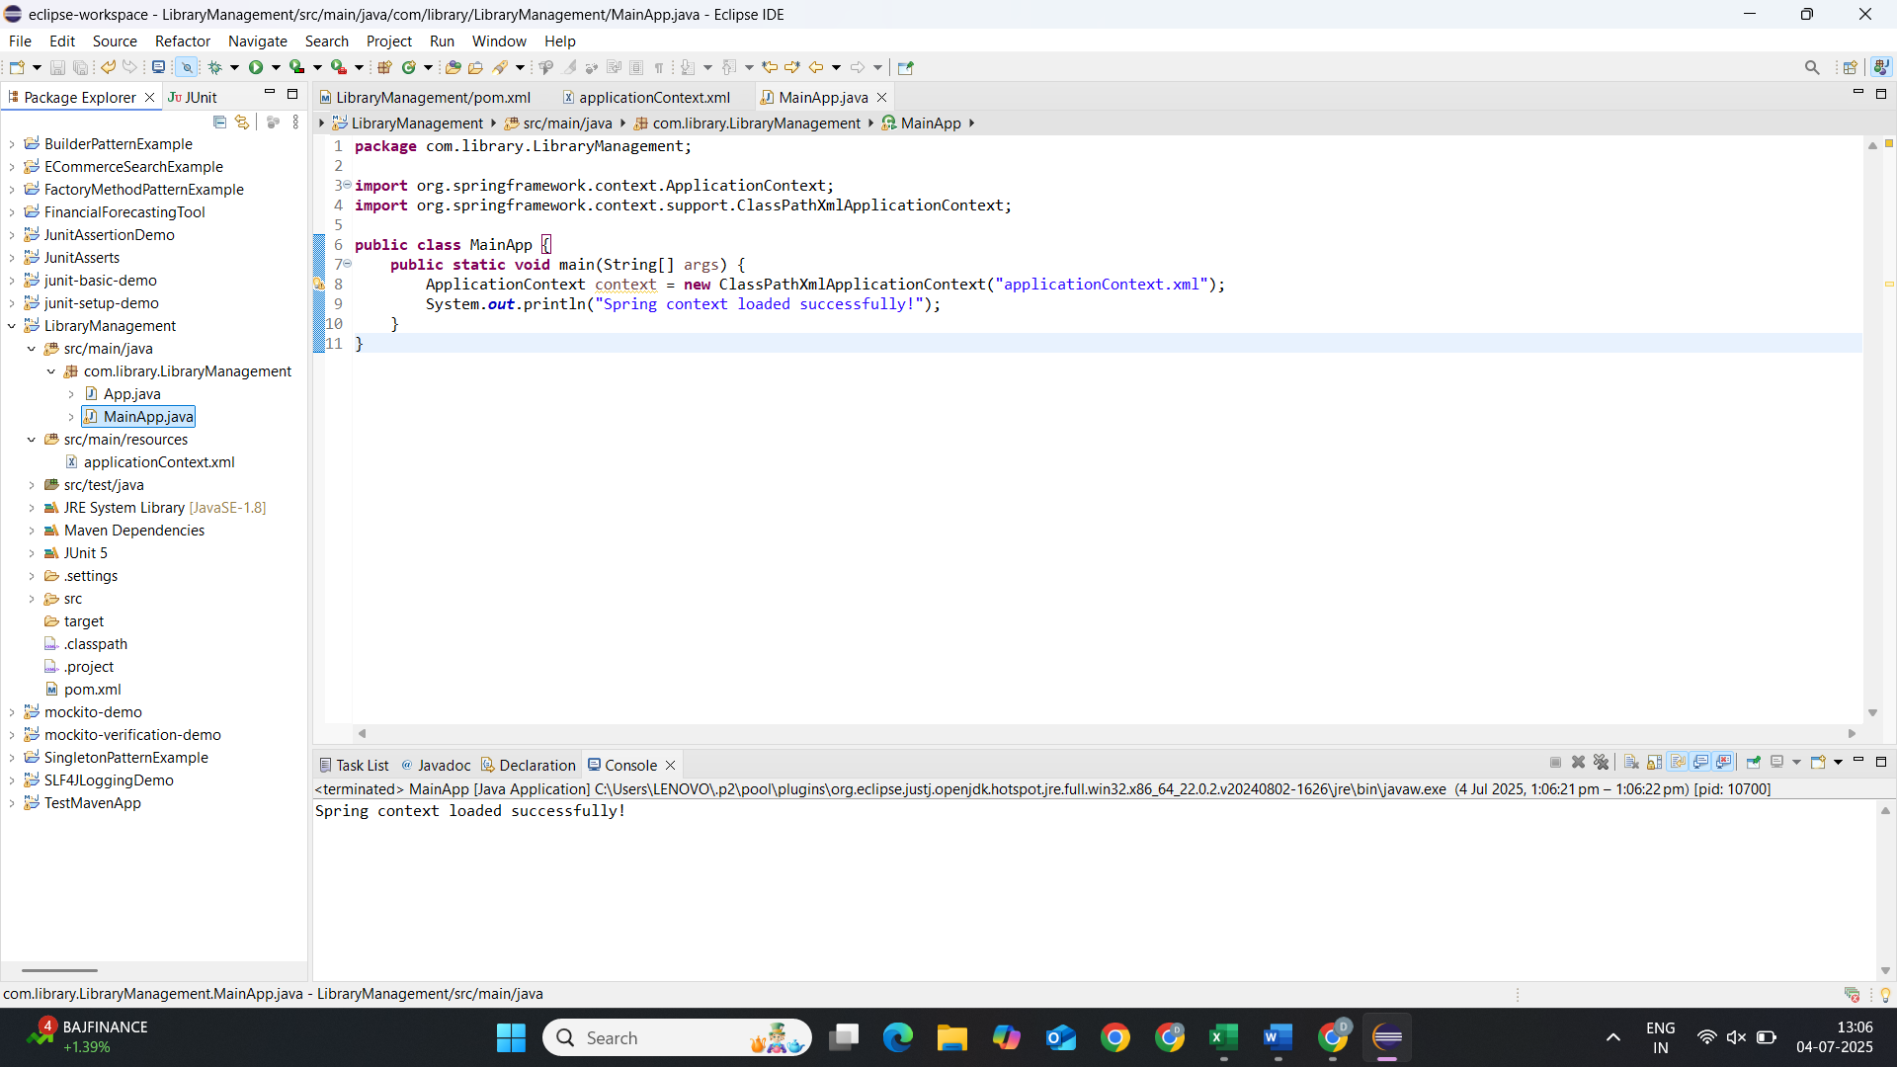

**Exercise 5: Configuring the Spring IoC Container**

**pom.xml :**

<?xml version="1.0" encoding="UTF-8"?>

<project xmlns="http://maven.apache.org/POM/4.0.0"

xmlns:xsi="http://www.w3.org/2001/XMLSchema-instance"

xsi:schemaLocation="http://maven.apache.org/POM/4.0.0

https://maven.apache.org/xsd/maven-4.0.0.xsd">

<modelVersion>4.0.0</modelVersion>

<groupId>com.library</groupId>

<artifactId>LibraryManagement</artifactId>

<version>1.0.0</version>

<packaging>jar</packaging>

<properties>

<project.build.sourceEncoding>UTF-8</project.build.sourceEncoding>

<java.version>1.8</java.version>

<spring.version>5.3.29</spring.version>

</properties>

<dependencies>

<!-- Spring Core Container -->

<dependency>

<groupId>org.springframework</groupId>

<artifactId>spring-context</artifactId>

<version>${spring.version}</version>

</dependency>

<!-- Spring Beans -->

<dependency>

<groupId>org.springframework</groupId>

<artifactId>spring-beans</artifactId>

<version>${spring.version}</version>

</dependency>

<!-- Spring Core -->

<dependency>

<groupId>org.springframework</groupId>

<artifactId>spring-core</artifactId>

<version>${spring.version}</version>

</dependency>

<!-- Spring Expression Language (SpEL) -->

<dependency>

<groupId>org.springframework</groupId>

<artifactId>spring-expression</artifactId>

<version>${spring.version}</version>

</dependency>

</dependencies>

<build>

<plugins>

<!-- Maven Compiler Plugin -->

<plugin>

<groupId>org.apache.maven.plugins</groupId>

<artifactId>maven-compiler-plugin</artifactId>

<version>3.8.1</version>

<configuration>

<source>${java.version}</source>

<target>${java.version}</target>

</configuration>

</plugin>

<!-- Maven Resources Plugin -->

<plugin>

<groupId>org.apache.maven.plugins</groupId>

<artifactId>maven-resources-plugin</artifactId>

<version>3.2.0</version>

<configuration>

<encoding>${project.build.sourceEncoding}</encoding>

</configuration>

</plugin>

</plugins>

</build>

</project>

**applicationContext.xml :**

<?xml version="1.0" encoding="UTF-8"?>

<beans xmlns="http://www.springframework.org/schema/beans"

xmlns:xsi="http://www.w3.org/2001/XMLSchema-instance"

xsi:schemaLocation="http://www.springframework.org/schema/beans

http://www.springframework.org/schema/beans/spring-beans.xsd">

<!-- BookRepository Bean Definition -->

<bean id="bookRepository" class="com.library.repository.BookRepository"/>

<!-- BookService Bean Definition with Dependency Injection -->

<bean id="bookService" class="com.library.service.BookService">

<property name="bookRepository" ref="bookRepository"/>

</bean>

</beans>

**BookRepository.java :**

package com.library.repository;

public class BookRepository {

public String getBookInfo() {

return "Book details from repository";

}

}

**BookService.java :**

package com.library.service;

import com.library.repository.BookRepository;

public class BookService {

private BookRepository bookRepository;

// Setter method for dependency injection

public void setBookRepository(BookRepository bookRepository) {

this.bookRepository = bookRepository;

}

public String getBookDetails() {

return bookRepository.getBookInfo();

}

}

**LibraryApp.java :**

package com.library.LibraryManagement;

import org.springframework.context.ApplicationContext;

import org.springframework.context.support.ClassPathXmlApplicationContext;

import com.library.service.BookService;

public class LibraryApp {

public static void main(String[] args) {

// 1. Load the Spring IoC container

ApplicationContext context =

new ClassPathXmlApplicationContext("applicationContext.xml");

// 2. Get the BookService bean

BookService bookService = context.getBean("bookService", BookService.class);

// 3. Use the service

System.*out*.println("Book Details: " + bookService.getBookDetails());

// 4. Close the context

((ClassPathXmlApplicationContext) context).close();

}

}

**OUTPUT :**

